**Video Compression**

**Aniruddh Kumar Tiwari Ashwini Chitturi JayaShree Ketha Priyotosh Saha  
MT24015 MT24021 MT24042 MT24068**

**Abstract**

Video compression plays a crucial role in reducing the storage and transmission requirements for video files, without compromising on visual and audio quality. In this report, we discuss the steps involved in a video compression pipeline, including frame extraction, scene change detection, spatial compression using DCT (Discrete Cosine Transform), and the reconstruction of intermediate frames using optical flow techniques. We explore the process from input to decompressed output, highlighting compression techniques such as spatial compression and shot boundary detection (SBD), along with the challenges faced during decompression. The objective is to compress a video file by extracting keyframes, compressing them, and then reconstructing the video with minimal loss in quality.  
  
**1)Introduction**Video compression reduces the size of video files by eliminating redundancies while maintaining visual and auditory quality. It is crucial for streaming platforms, cloud storage, and video conferencing to ensure efficient data transmission over limited bandwidth. With the exponential growth of video content, effective compression is vital for cost efficiency and user satisfaction.

**Purpose of the Project**This project aims to explore and implement video compression techniques that balance file size reduction and quality preservation. By combining scene change detection, DCT for spatial compression, and optical flow for frame interpolation, we evaluate the efficiency of these methods in a practical workflow. The ultimate goal is to develop an effective compression-decompression pipeline and identify challenges in achieving optimal results.

**2)Data Preprocessing - EDA  
Input**

The input to the compression system is an original video file, which typically contains multiple frames with varying levels of visual content, motion, and

audio. The video is processed frame by frame to identify scene changes and to apply appropriate compression techniques. The original video is used for both   
  
 **Expected Output**The expected output is a decompressed video that closely resembles the original video in terms of both visuals . While the decompressed video may have some loss in quality due to compression, the goal is to minimize this degradation. The output should consist of the following:

**Decompressed Video**: This video should retain the original content, including keyframes and intermediate frames reconstructed using motion estimation techniques.  
**Compression Ratio**: The compression algorithm should achieve a significant reduction in file size while maintaining acceptable quality for both video and audio.

The first step in the video compression process is Exploratory Data Analysis (EDA), where several important video characteristics are examined:

**Frame Extraction**: The video is analyzed frame by frame, extracting individual images that represent the visual content at each point in time.  
**Frame Visualization**: Visualizing the extracted frames allows for inspection of the content, scene changes, and potential areas for compression.  
**FPS (Frames Per Second)**: The FPS is calculated to understand the video’s frame rate, which impacts compression performance. Higher FPS values typically require more complex compression techniques to preserve quality.  
**Histogram Analysis**: Histograms of the frames are analyzed to identify areas with high or low complexity, which helps in applying appropriate compression techniques.  
**Audio Extraction**: The audio is extracted from the video file and analyzed for compression opportunities

**3)Methodologies  
Compression techniques**

**Spatial Compression using DCT (Discrete Cosine Transform)**: DCT is applied to the keyframes to perform spatial compression. This technique transforms the image into a frequency domain, where high-frequency components (often representing noise and minor details) are discarded, leaving only the most important visual features for reconstruction.

**Shot Boundary Detection (SBD)**: SBD techniques are employed to identify scene changes or transitions. These transitions are used to select keyframes, which are the only frames retained for compression. Scene changes are detected using metrics like color histograms, edge detection, or motion estimation.

**Optical Flow and Motion Estimation**: Optical flow techniques are used to detect and track motion between adjacent frames. This allows the system to reconstruct intermediate frames between keyframes, using motion vectors that describe the displacement of pixels across frames.

**Interpolation**: After detecting motion vectors, interpolation techniques are applied to generate intermediate frames between keyframes, providing smooth transitions and reducing the need for storing every frame in the video.

**Decompression Techniques and Challenges**

The decompression process involves reversing the compression steps to reconstruct the original video. However, several challenges arise during decompression:

**Inverse DCT (IDCT)**: The DCT is reversed using IDCT to reconstruct the spatial domain of the keyframes. This step requires careful handling to minimize visual degradation during the inverse transform.

**Reconstruction of Intermediate Frames**: The intermediate frames are reconstructed using the motion vectors generated by optical flow and interpolation. This step can introduce artifacts if the motion estimation is not precise, leading to visible distortions in the decompressed video.

**Lossy Compression**: Both spatial compression (DCT) and motion estimation techniques are lossy, meaning some visual information is inevitably discarded during compression. The challenge lies in achieving a good balance between compression ratio and quality loss.

**Challenges faced - Frame Rate Adjustment Issues:**Decreasing FPS: Reducing the FPS resulted in a frame-by-frame playback, creating a noticeable pause effect between frames, leading to choppy video playback.  
Increasing FPS: Increasing the FPS to smoothen playback introduced visible artifacts, such as motion blur and unnatural transitions, due to the lack of accurate intermediate frame data.  
These issues highlighted the difficulty in maintaining visual fluidity while preserving compression benefits.  
  
**4)Evaluation Metrics  
Compression ratio  
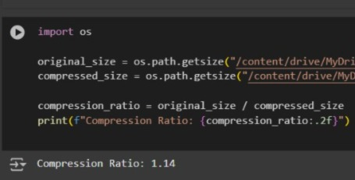  
MAE and PSNR  
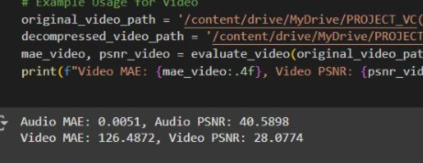  
Euclidean Distance  
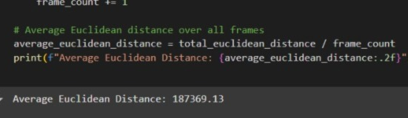**

**References**   
Key Frame Extraction Based On Motion Vector  
[https://link.springer.com/chapter/10.1007/978-3-319-  
48896-7_38?fromPaywallRec=false#Sec3](https://link.springer.com/chapter/10.1007/978-3-319-48896-7_38?fromPaywallRec=false#Sec3)   
  
  
<https://youtu.be/Q2aEzeMDHMA?si=xAn_9IzrdJ4Kr8Sb>